Name | JAMES PEARSON BLYTHE
Birth | 1880 Heddon-on-the-wall, Northumberland
Enlistment/Occupation | Hexham 04/12/1915 / Mason’s Labourer
Death, date, location | 22/04/1917  Killed in action  France & Flanders
Age | 36
Unit, rank, service no: | 89309  Gunner  Royal Garrison Artillery  230th Siege Bty.
Photograph Hexham Courant 21/07/1917 | 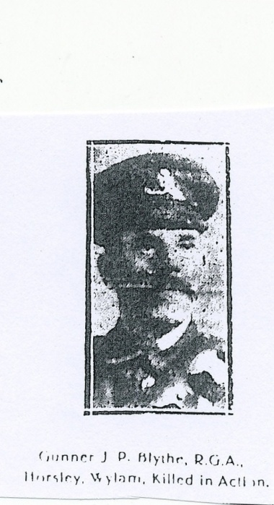
Family | James Pearson Blythe first appears in the 1881 census as a 6 month old son of Charles Blythe, a 29 year old bricklayer from Marsham Norfolk and his wife Sarah Margaret (nee Pearson) from Newcastle. James was the third child and the family were living in a cottage at Houghton Moor, just west of Heddon on the Wall village and were still there in 1891, but now with seven children at home and a 76 year old aunt living in. By 1901 the family had moved to Horsley Hills near North Side Farm and the two adult sons were in employment. James aged 20 was a mason’s labourer and his elder brother Joshua aged 25 was a stonemason. The others at home with the parents were Eleanor 23, Honor 14, Mary 11, Hannah 9, and Robert 8.  Three years later on 1st October 1904 James married Mary Jane (Jennie) Carr the eldest daughter of a neighbouring family of Robert and Annie Carr.  (sadly: Mary Jane’s own youngest brother Edward Carr born 1897 was killed in action 14/02/1916 one year before her own husband James Pearson Blythe. (See under Edward Carr)  The 1911 census shows James aged 29 and Jennie Blythe aged 28 and their young son Ernest James aged 6 (b. 24/03/1904) living in a separate cottage in Horsley. James was a labourer. His military records show that a daughter Florence Margaret was born 08/04/1912.  After enlisting at Hexham in December 1915, James served with the Royal Garrison Artillery; crossing to France in January 1917.  There was a report in the Hexham Courant 21/07/1917 recording that Gunner Blythe was killed by a shell burst. He was the 36 year old husband of Mrs. J. Blythe and son of Mrs. Sarah and late Mr. Charles Blythe of North Cottage, Horsley. There was a photograph attached to the article.  James military service records show that his wife Mary Jane was awarded a widow’s pension in respect of herself and her two children valued at £1..2s..11p. per week to commence 19/11/1917.
Royal Garrison Artillery  230 Siege battery | The role of the Siege Battery  Siege Batteries RGA were equipped with heavy howitzers, sending large calibre high explosive shells in high trajectory, plunging fire. The usual armaments were 6 inch, 8 inch and 9.2 inch howitzers, although some had huge railway- or road-mounted 12 inch howitzers. As British artillery tactics developed, the Siege Batteries were most often employed in destroying or neutralising the enemy artillery, as well as putting destructive fire down on strongpoints, dumps, store, roads and railways behind enemy lines.  There would be similar heavy calibre German artillery returning fire attempting to neutralise the british heavy artillery. It is recorded that James was killed by a shell burst which probably means the German artillery had successfully located the battery that James and his comrades were operating on.  230 Siege Battery was posted to France 18th January 1917 they embarked at Southampton and disembarked at L’Havre. James was killed 22nd May 1917
War Grave | I. G. 15.  ST. NICOLAS BRITISH CEMETERY  Arras  Also commemorated on:-  War memorial Plaque St.Oswin’s church, Wylam  War Memorial cross, Horsley village
Comments | James Pearson Blythe’s military service records are available and provide personal details, dates & places relevant to his service.  Home service 04/12/1915- 17/01/1917  France 18/01/1917 – 22/04/17  KIA 22/04/1917
Sources | British Army WWI Service Records 1914-20  UK Soldiers died in the Great War1914-1919  Commonwealth War Graves Commission  1881/1891/1901 & 1911 Census  www The Long Long Trail  Hexham Courant 21/07/1917 (photo) James Pearson Blythe son of Mrs. Sarah M. Blythe and the late Mr. Charles Blythe (former bricklayer) North Cottages, Horsley.

